**IFT 458/598: Middleware Prog & Database Security (Fall 2022)**

Saurabh Verma

Module 3 Assignment Data Access

Instructor: Dinesh Sthapit

October 2, 2022

**Module 3 Assignment Data Access**

Steps followed while executing this project are:

Step 1: Created a new project folder and added a package:

Step 2: Installed necessary modules such as dotenv, mssql, morgan and cors:

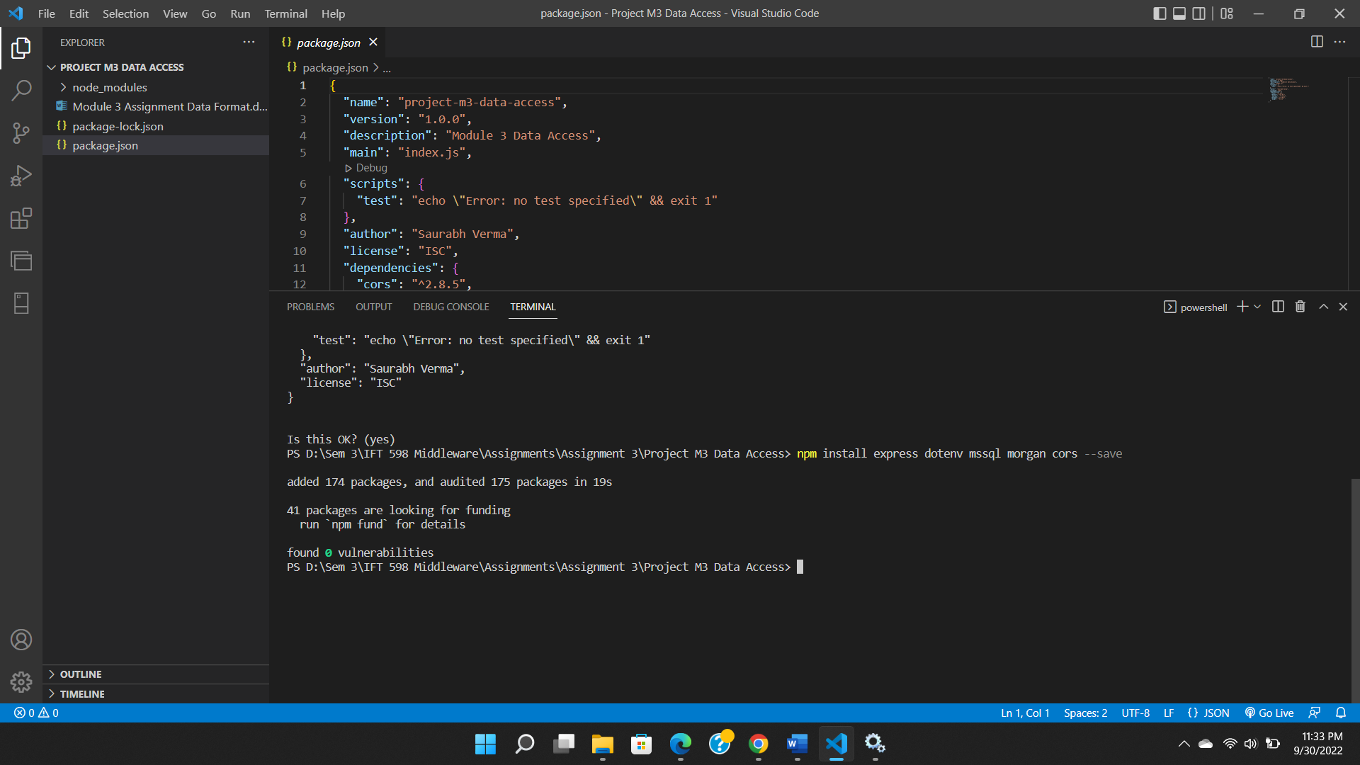

Step 3: Added app code in app.js file:

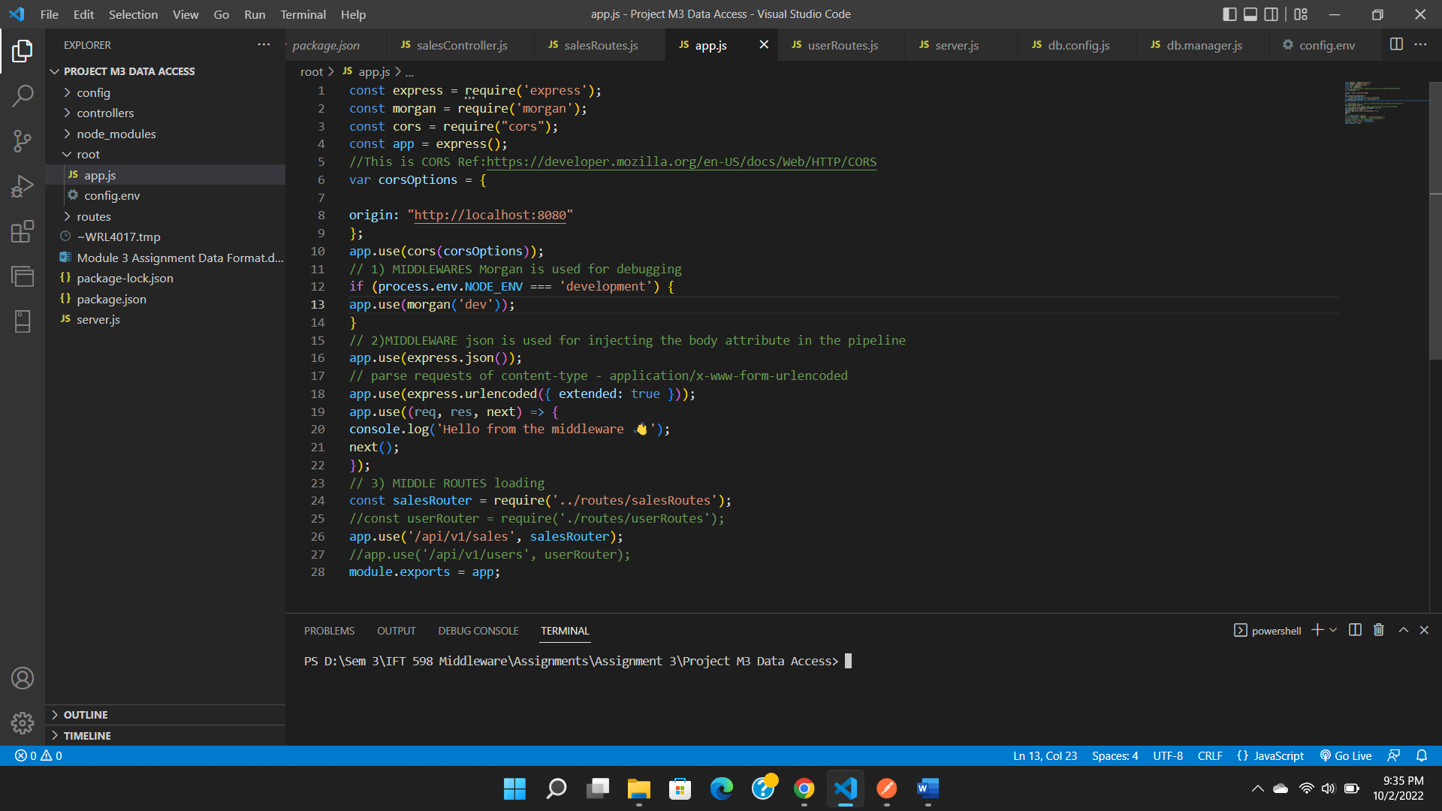

Step 4: Creating a server.js file:

Step 5: Created config.env file in root folder:

Step 6: Installing mssql and creating db.config.js:

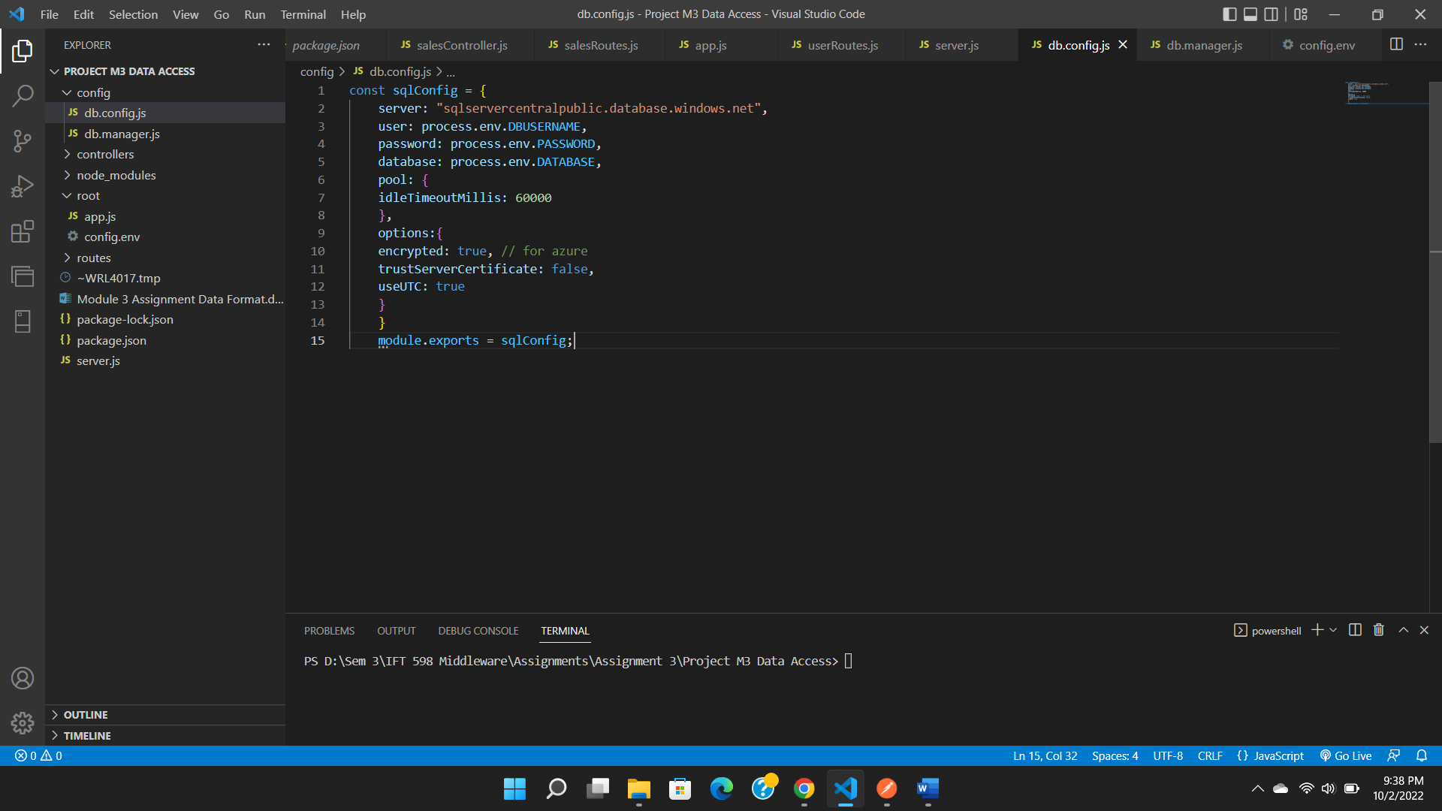

Step 7: Creating db.manager.js:

Step 8a: Create a file in routes folder and name it salesRouter.js:

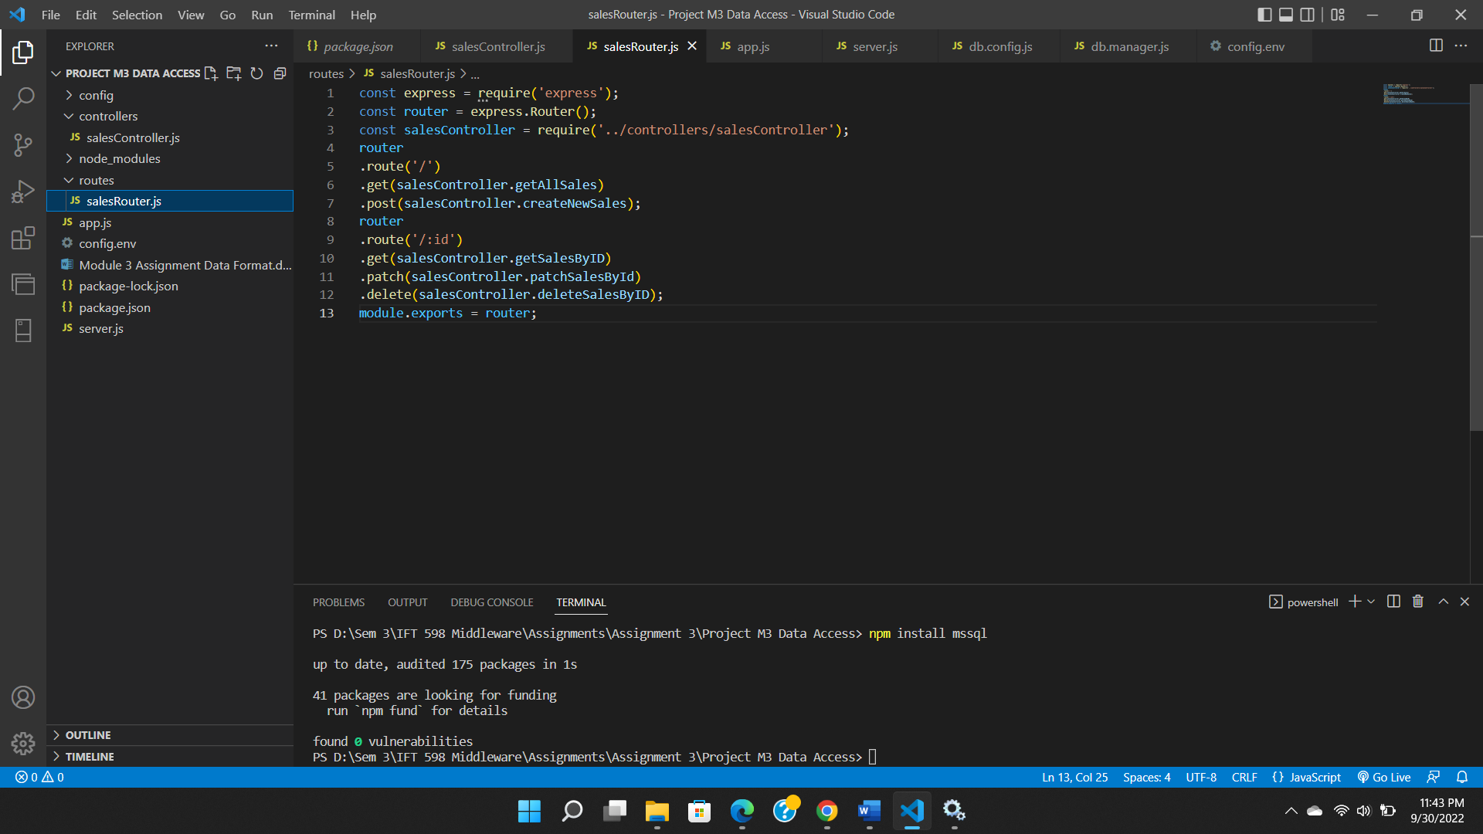

Step 8b: Create a file under controllers folder and name it salesController.js:

Now testing the APIs:

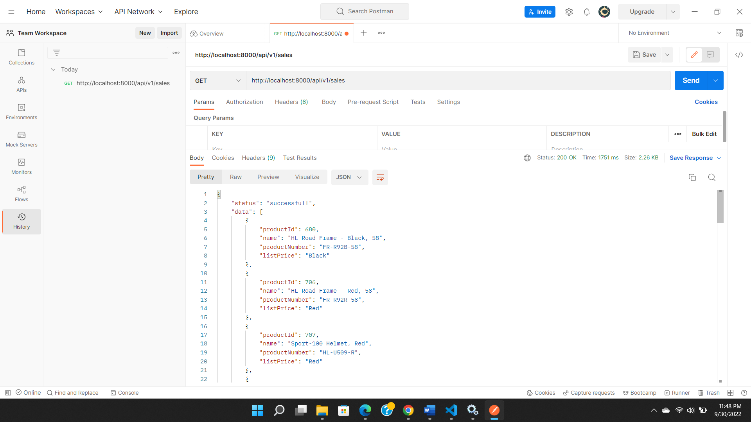

Additional requirements:

Creating successful connection to the database:

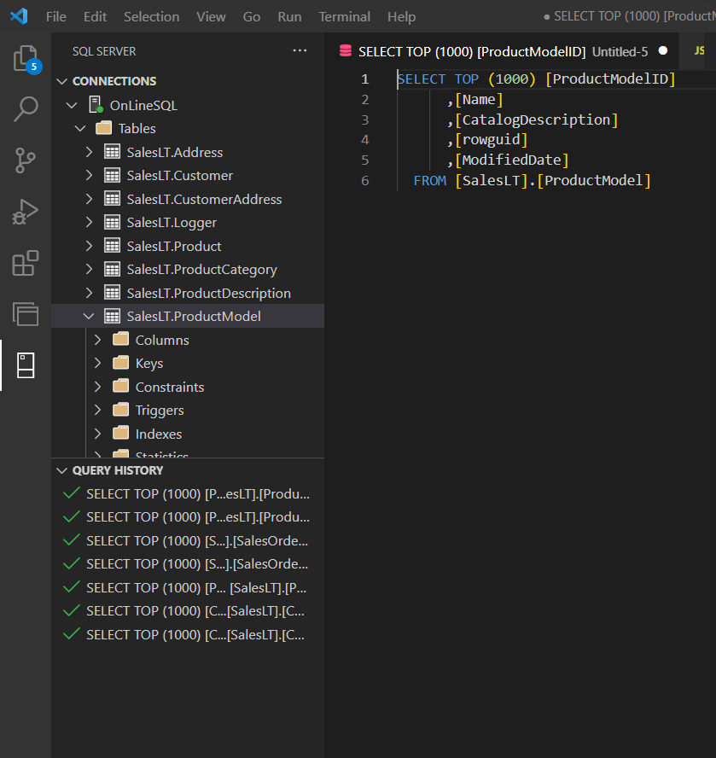

Screenshot of table views:

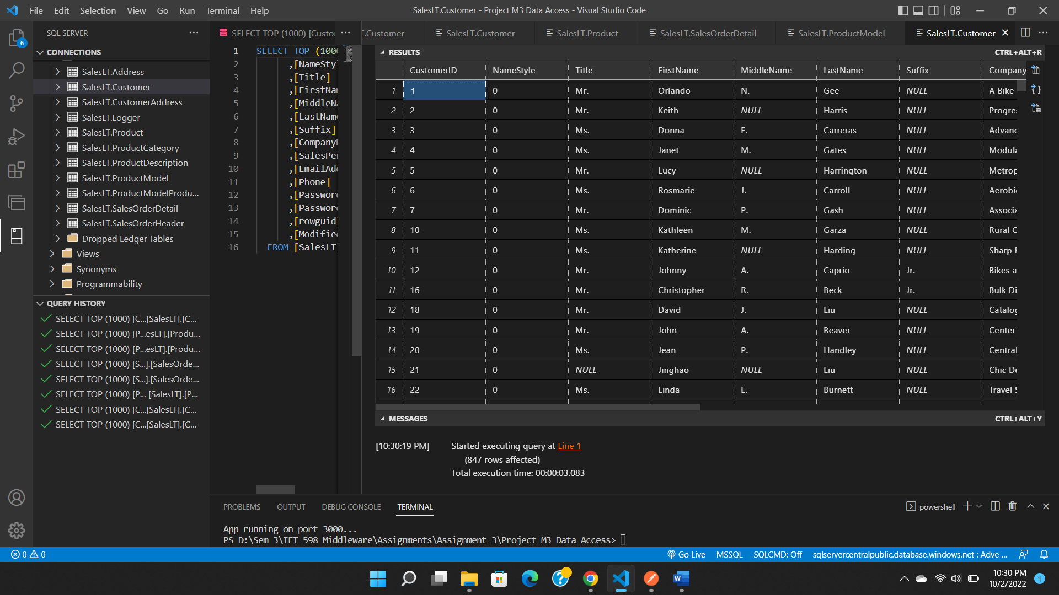

Created Correct Individual SQL SELECT Statement to Query Data in four Tables:

Provide the SQL Statements that you used to get Customers from the Database:

1.Select from saleslt.customer:

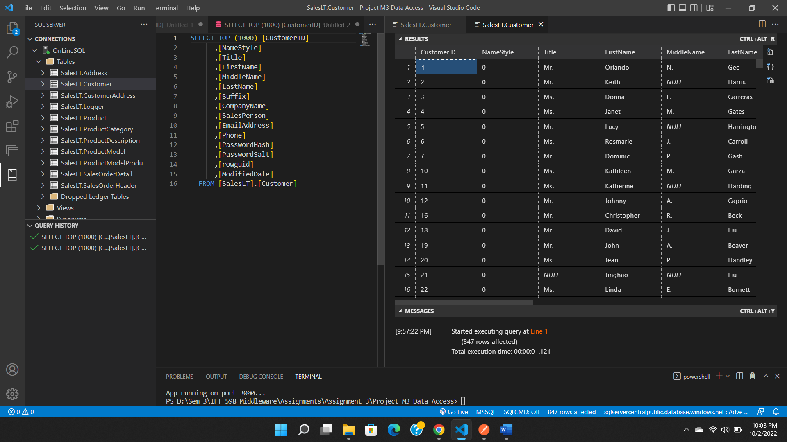

2.Select from saleslt.product:

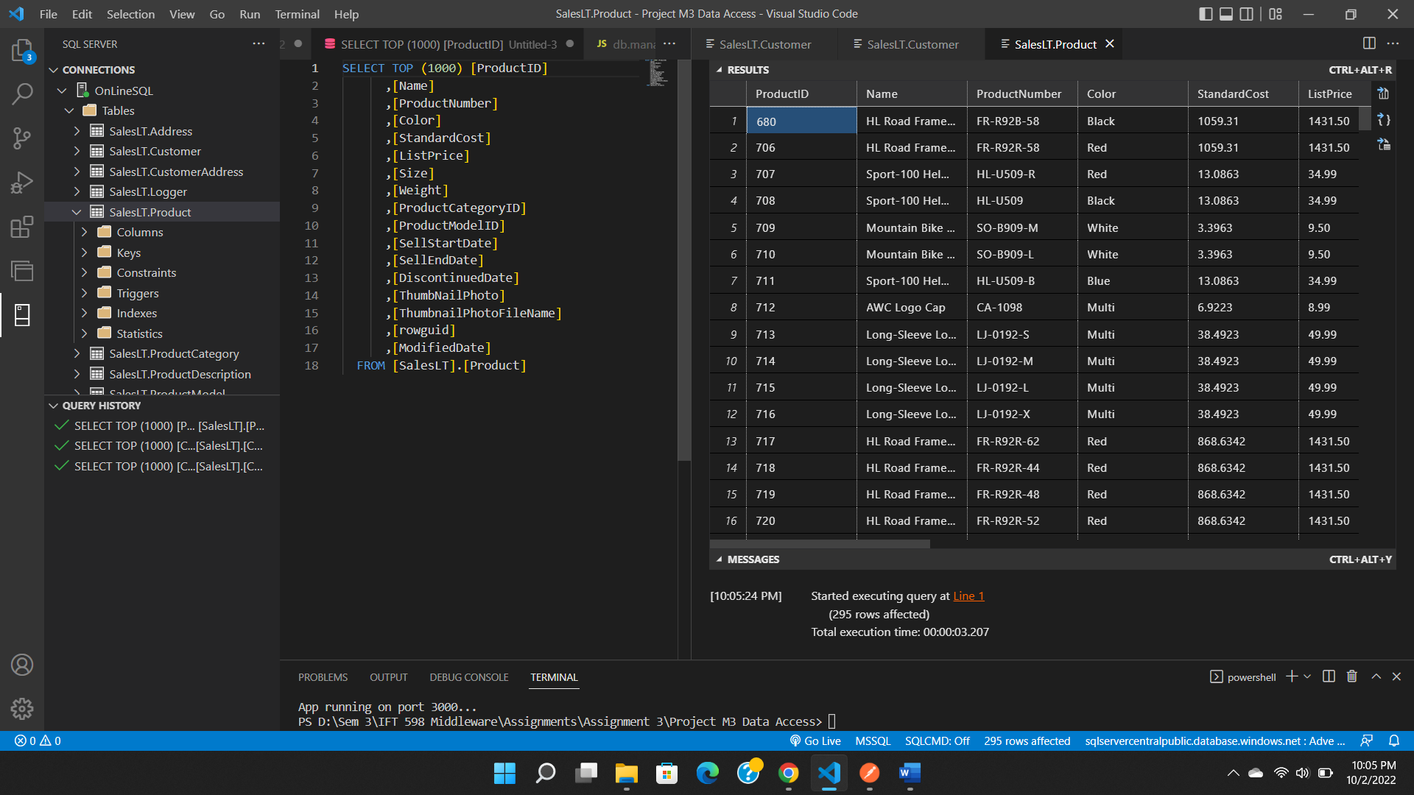

3.Select from saleslt.salesorderdetail:

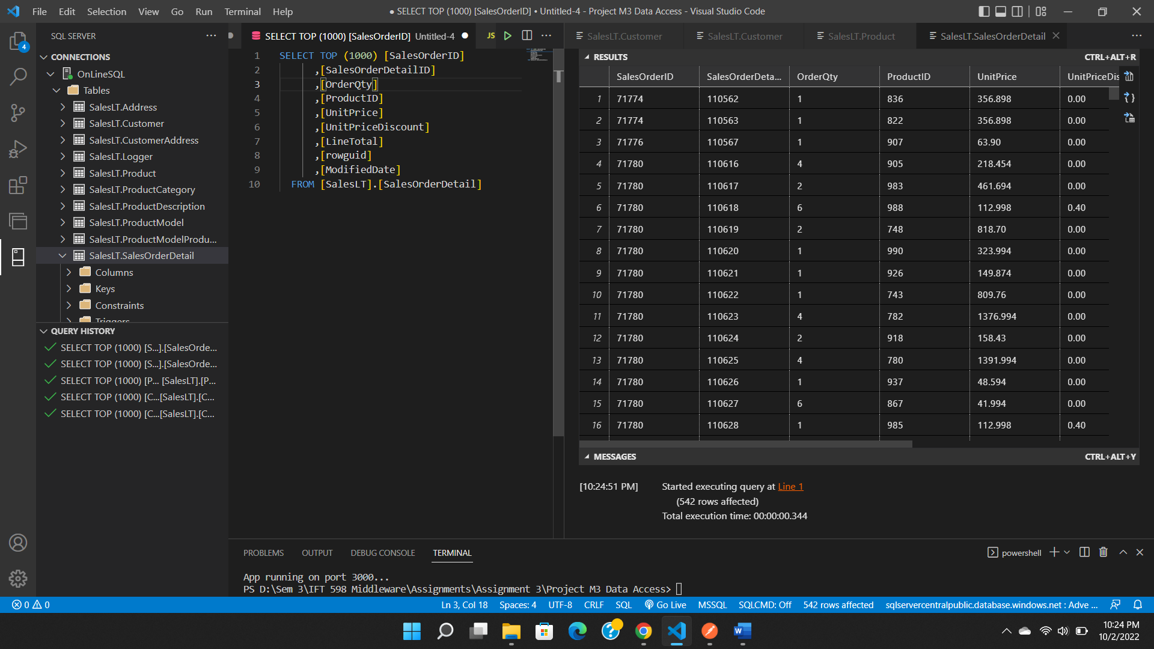

4.Select from saleslt.productmodel:

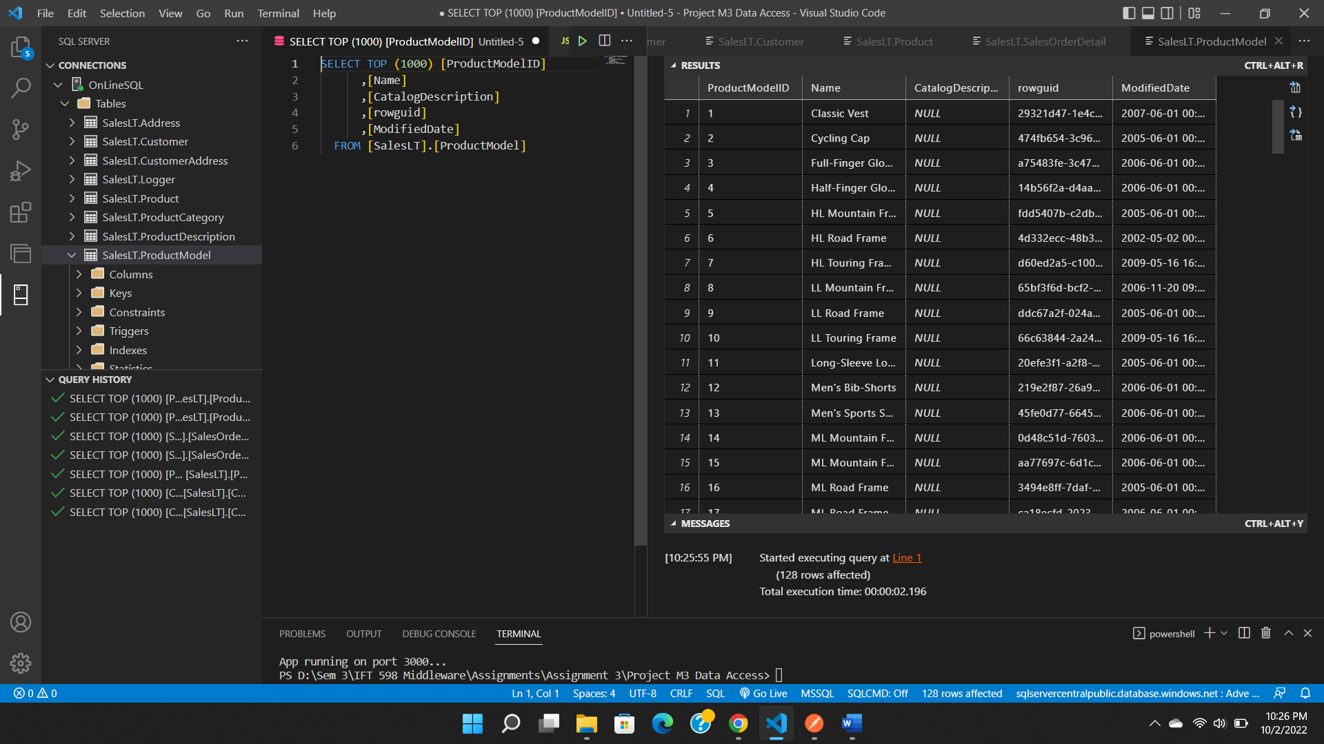

Show an example of joining two tables using COMPLETE SQL STATEMENTS with related data:

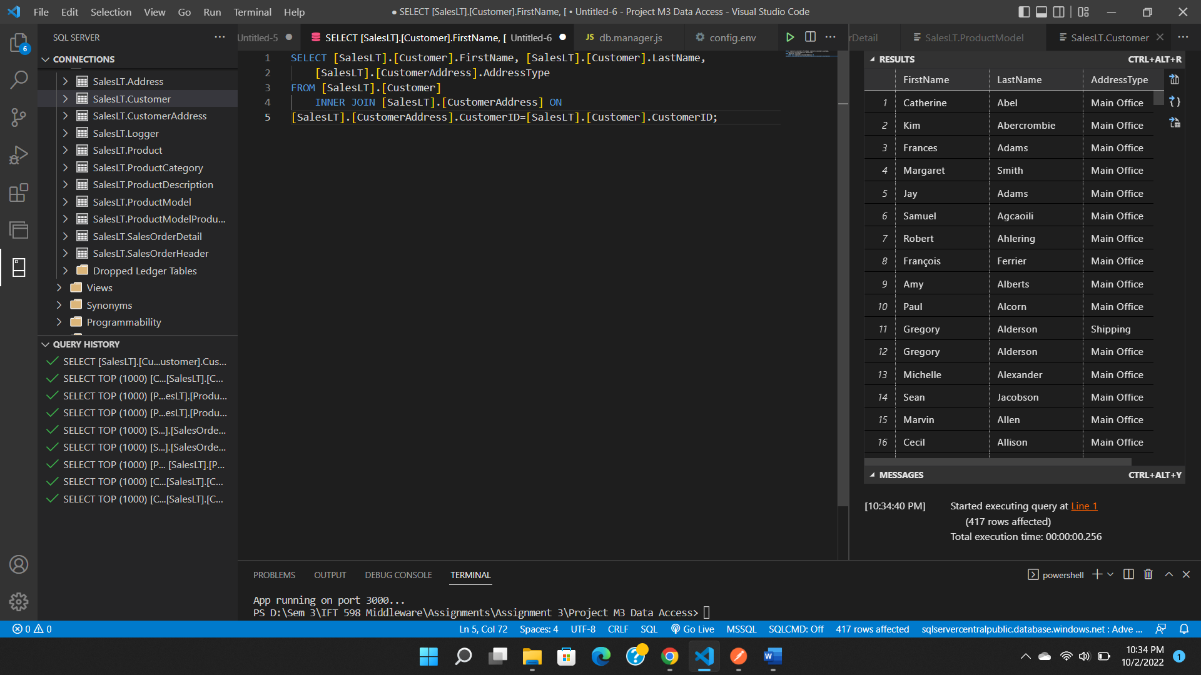

**References**

Source code: <https://drive.google.com/file/d/1665oBYn4oP1N3bEb67p6Fm4DWA689_MA/view>

GitHub repository: